**CHAPTER 5**

**SNAPSHOTS**

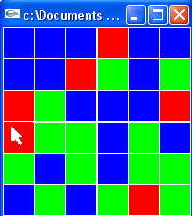

**Fig 5.1 INITIAL MATRIX OF SQUARES**

* Initially by creating default number of small color boxes of particular game that are placed randomly in a square box.

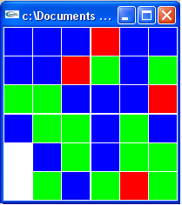

**Fig 5.2 CELL DELETION ON CLICK**

* On clicking the particular color box the cell got deleted from the square breaker game and remaining colored boxes shifted up and joined the above boxes.

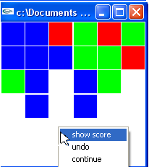

**Fig 5.3 MENU ITEMS**

* The pop-up menu that shows more features about the game. This option is open when we use right mouse button.

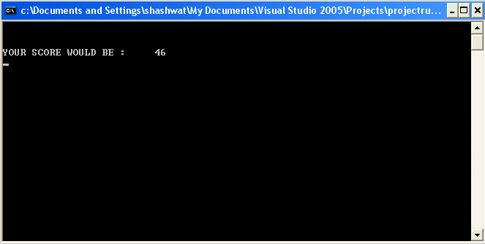

**Fig 5.4** **THE RESULT OF SELECTION OF SHOW SCORE OPTION**

* After choosing from the score options provided by the pop-up menu of the game, we can get the current score.

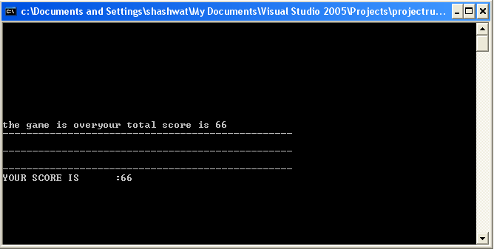

**Fig 5.5 THE FINAL SCORE DISPLAY ON END OF GAME**

* We will get the final score of the game when the game is over.

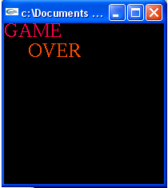

**Fig 5.6 END OF GAME WINDOW**

* This shows the end of the game.